Home Page

HTML Tags => <!DOCTYPE html> , <html> </html>, <head></head>, <title></title>, <body></body>

Meta tag => Viewport for flexible window adjustment

External CSS style sheet => mystyle.css

Internal CSS style for social media icons => <style> </style> tag into the head tag

Body tag include background image

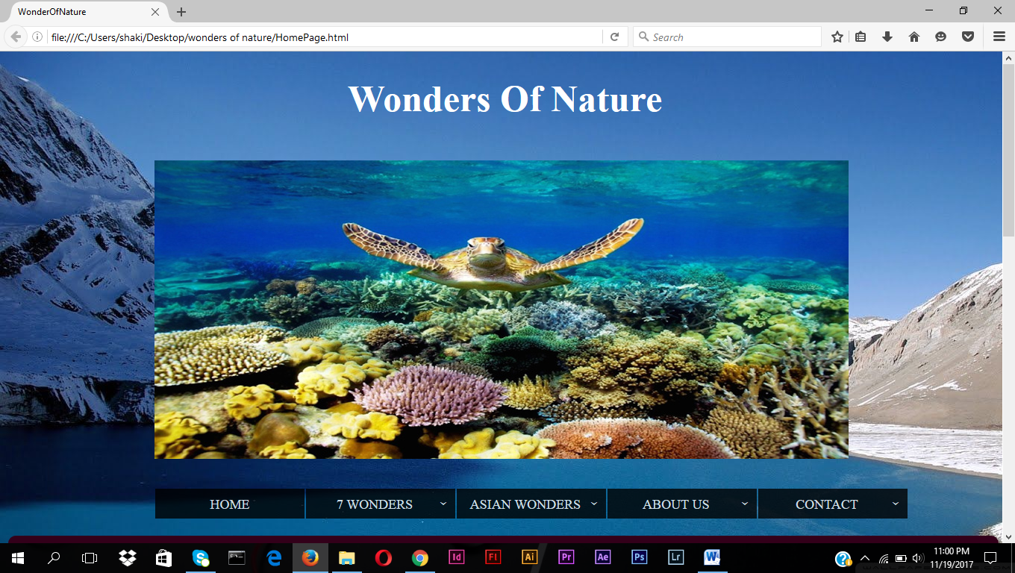

Wonders of Nature => Using HTML tag <h1> ,Inline CSS style tag for margin-left, color(font)

Animation 7 wonders pictures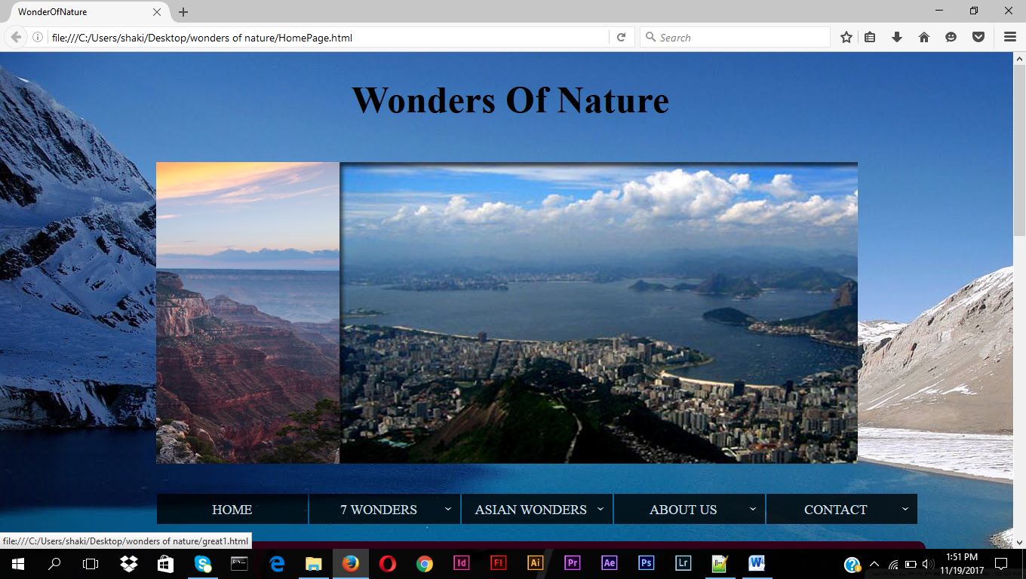

* Divided for outer box & slider box for using these id give the CSS styles for that particular division
* Image tag
* <a href=”” target=”_blank”> </a> . a href ->link on images target_blank-> open the link in new window

Drop down navigation bar => 5 Titles = >Home, 7 wonders, Asian Wonders, About Us, Contact.

* Some titles have sub titles such as
* 7 wonders has Grand Canyon, Great Barrier Reef, Harbour of io de Janiero, Mount Everest, Victoria_Falls, Northern Lights, Paricutin Volcano
* Asian Wonders has Nile River, Son Doong Cave, Dead sea, Mount Kilimanjaro, Nogrongoro Crater
* About Us has Our Thought & Resourses
* Contact has Join with Us & Map
* Every Titles and some titles have HTML link
* <ul> & <li> tags using for list the all titles with bullet style
* Using <span> tag for add a class attribute for sub-arrow which is used to identify the subtitles in the titles

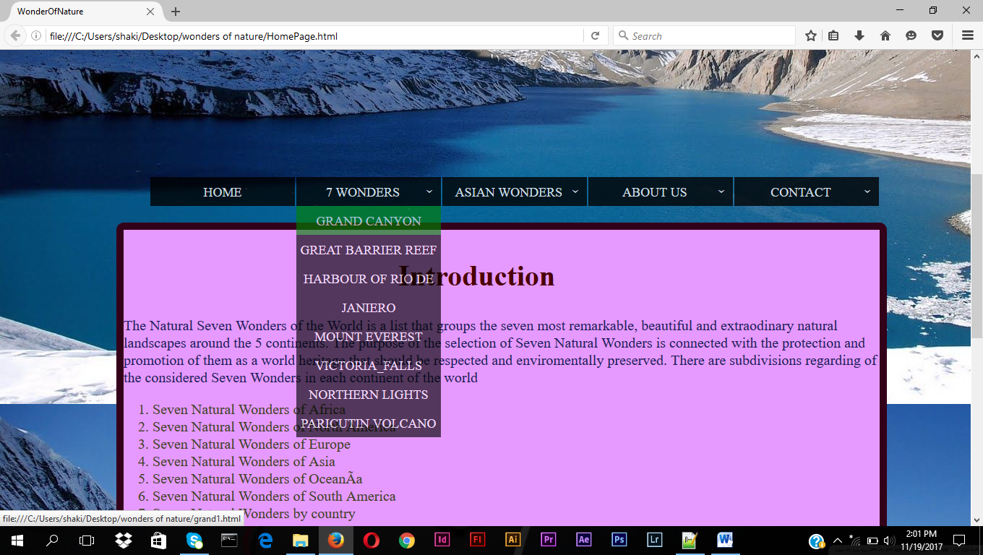

Introduction part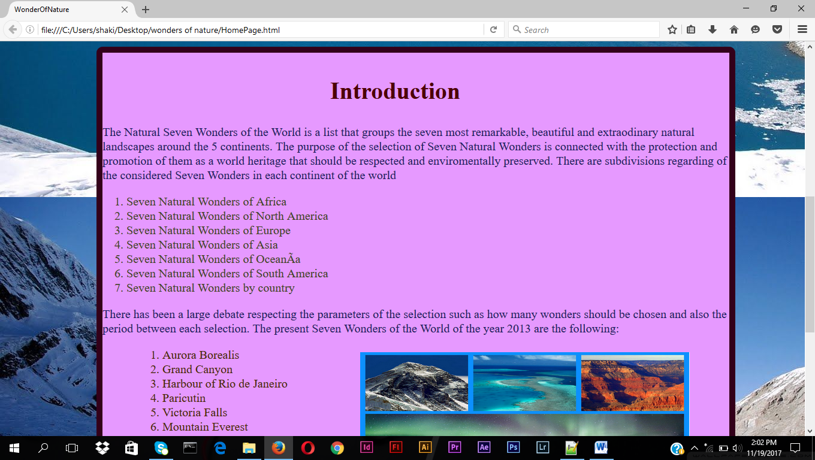

* Using col-11 for dividing
* <div> tag has inline style attribute using for background-color, border, border-radius
* <h2> tag using for sub heading Introdution
* <h2 style=””> inline CSS such as margin-top, color(font), font-size
* <p> tag using for paragraph which has color(font), font-size
* <ol> <li> tag using for list the contents
* <img> tag has inline style tag such as width, height, margin

Footer

* Social media
* Dividing the column 12
* Dividing id wrapper for external CSS property
* <p> tag for a message Join us
* In the <p> tag has inline style attribute for font-style,font-color, margin & font-size
* <a href> tag for link the online facebook & twitter , which are already created by other web site
* Dividing box as a class attribute for external CSS

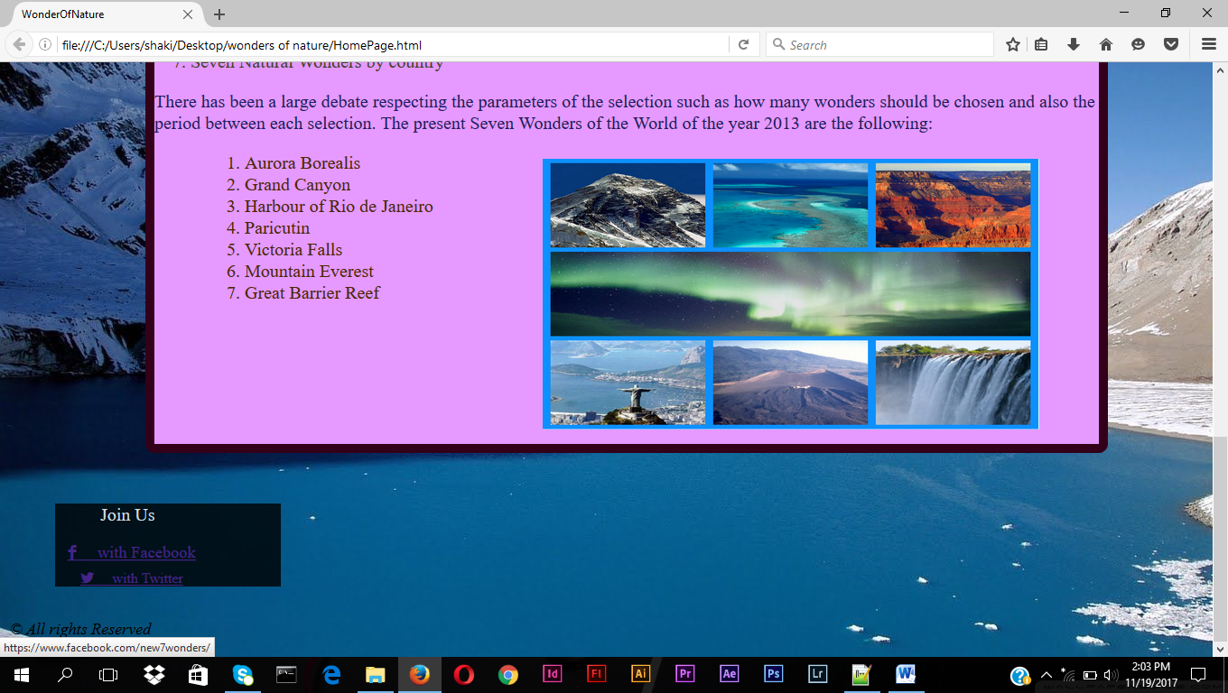

* <p> tag using for All rights Reserved
* <p> tag has inline style for margin-top, font-style, font-color & font-size

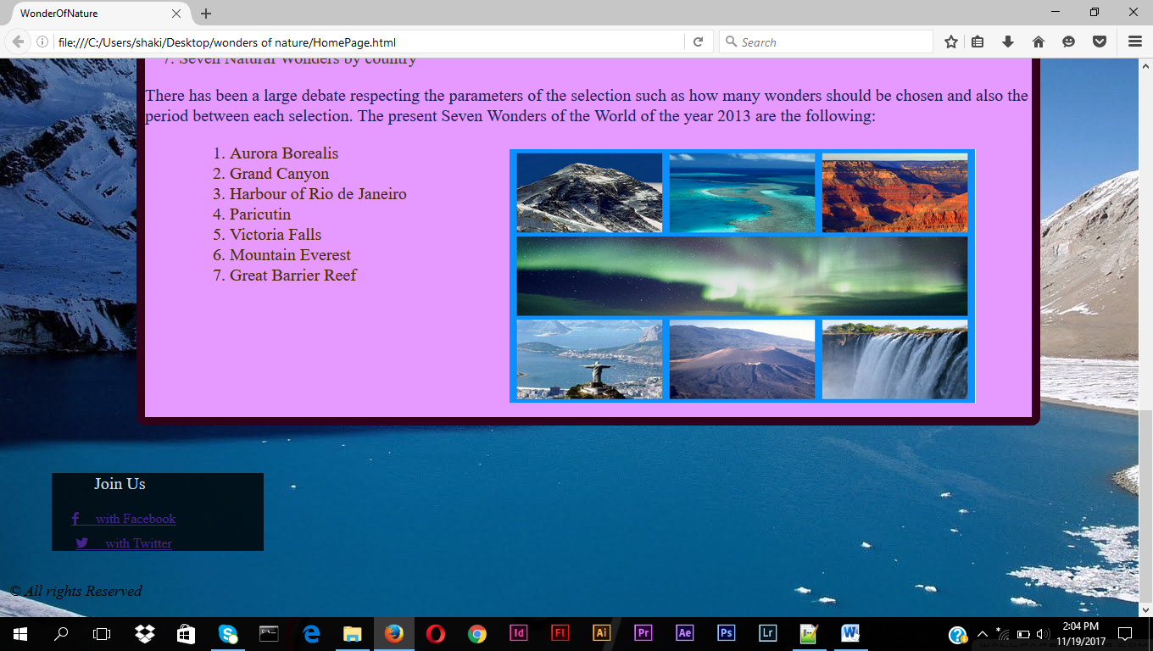

External CSS link => mystyle.css

* Outerbox =>It is box out of images. This is hidden the overflow of next images. Here I gave width ,that was width of image also

* Sliderbox => It is the box content that images. Here that position relative . I gave the width,that was sum of all 7 images width, The animation type is jatinder it is for 28 seconds infinite, that means the images slideshow continuity .
* Sliderbox img => Here float left that means images come to the left side
* Keyframes jatinder => Here seconds divided by no of images & each image can be appear on that particular time zone.
* Ul => Here the position absolute make content ,which behind the dropdown box make permanent place otherwise it will be moving. List-style none makes the bullets not visibile



* ul li =>Here float left makes list of the contents will be in row.Text-transform uppercase that makes the all content will visible on capital letters.The background color is black, so the opacity makes that black colour will be light.Other tags for the sizes for font ,line and text align center makes the names in center in each box.Margin right make a space between the titles.

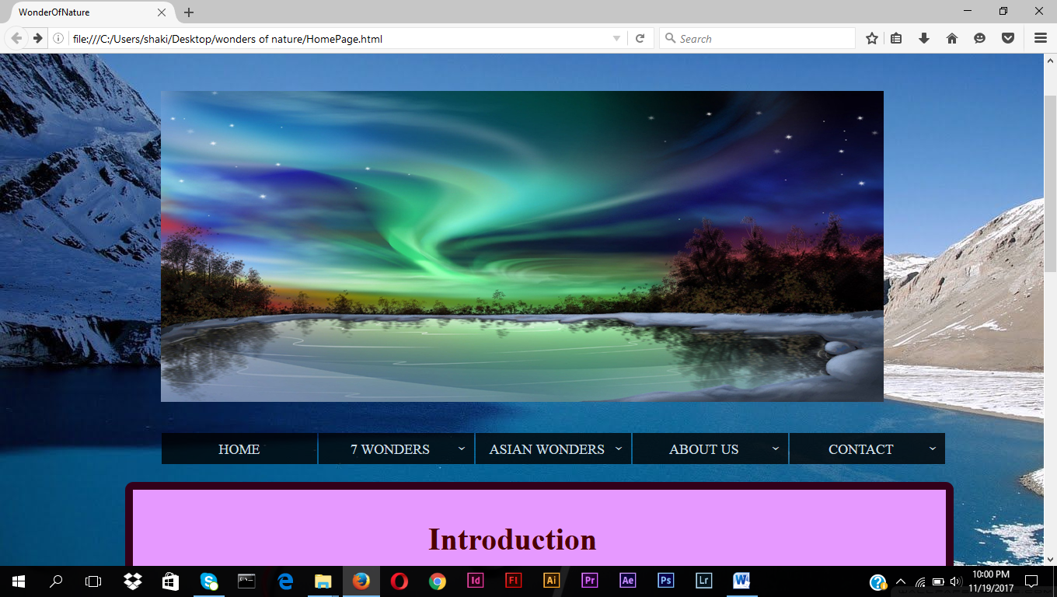

* Sub-arrow :after => The arrow after the navigation bar titles which has sub titles 
* ul li a => Here every link titles have color(font) white, text-decoration none means the links have not underline like that and display block means when the cursor point that titles it will visible block.

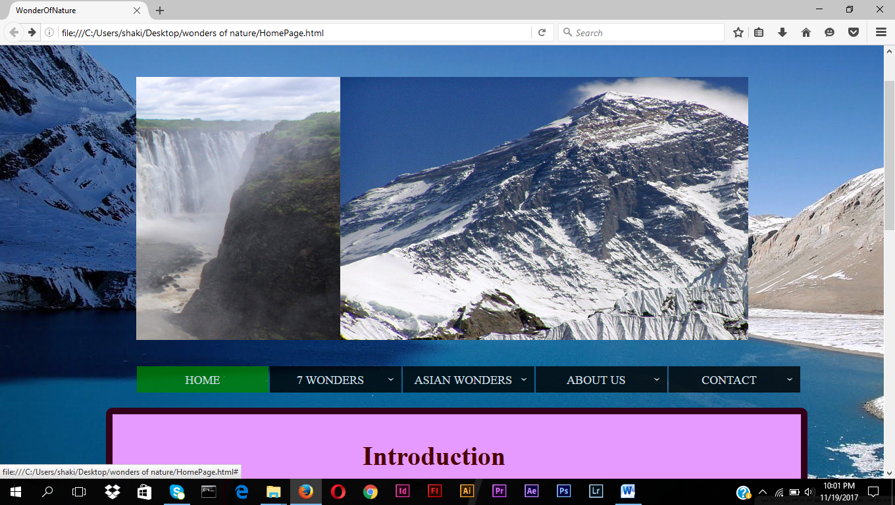

* ul li a :hover => This tag use for when the cursor point the titles background color will change green.



* ul li ul li =>Here display none means subtitles not visible .

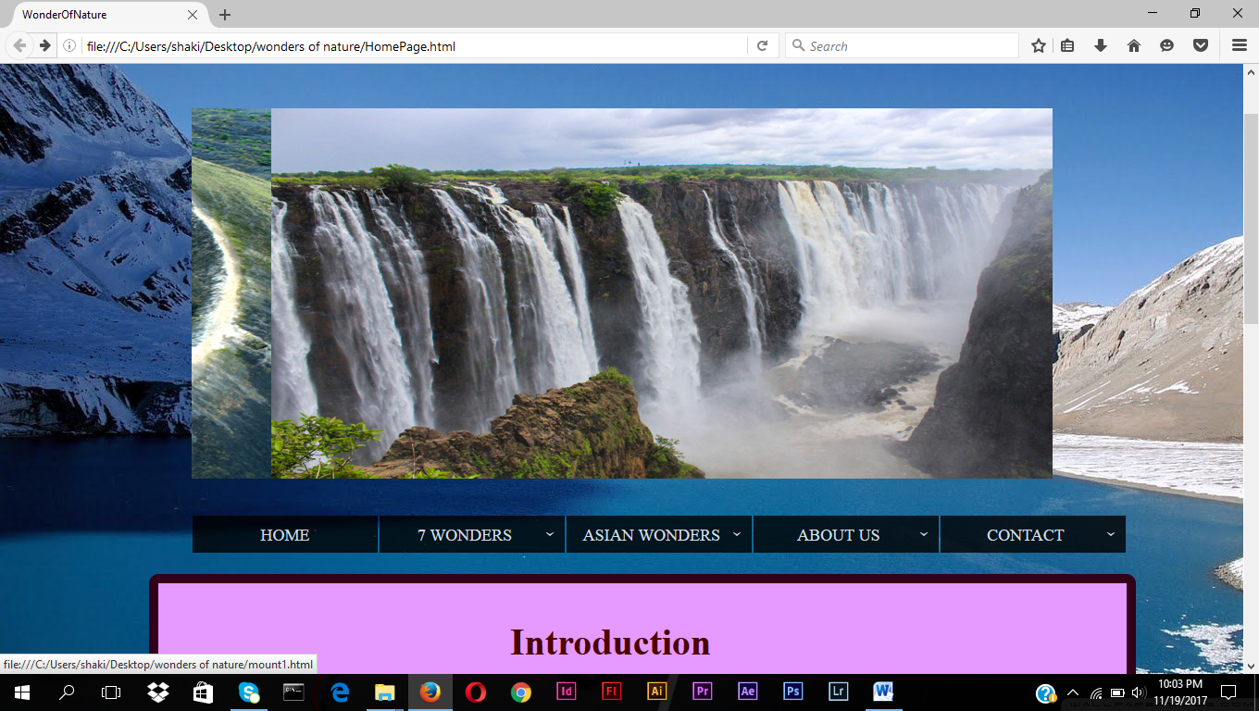

* ul li :hover ul l i => Display block means when we point the titles which has subtitles then subtitles will visible.



* h1=>Font size 50px make the wonders of nature heading will be big in size.
* Wrapper => Here social media button background width , height & margin tags

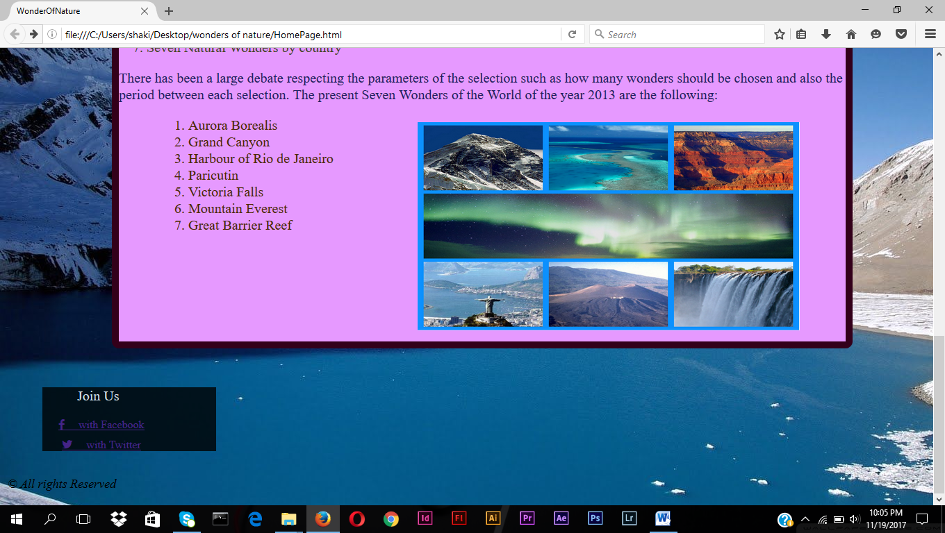

* Box => Here social media button styles and when cursor on that button it will point.
* box :hover => When the cursor on that point the color will change and 1s it will transform

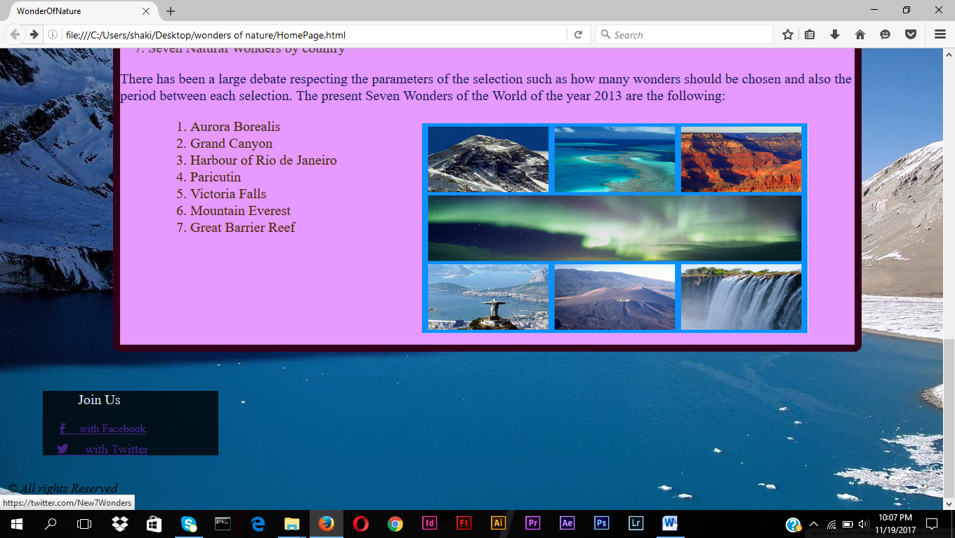

* col => Here divide the page by columns which have particular percentage with of whole page. Media query foe responsive web page.Resources

# Youtube channel

# w3schools.com